How to fix Ender 3 S1/S1 Pro ABL issues

The symptoms that this resolves are:

* The bed mesh shows it being higher in front, and lower in the back, or higher on one side than the other, or “ripples” or “waves” in the mesh.
* The bed mesh is just not accurate, resulting in poor first layers.

This guide is firmware agnostic.

After doing this, my bed levelling is 100% perfect, every time.

**IMPORTANT: Take a screenshot of your current bed level mesh using Octoprint, Mainsail, Fluidd, or whatever your favourite method is for doing so. We will be using this to compare, and verify that we made a difference.**

Here is my before and after, for an idea of the kind of improvement this makes:

Before:

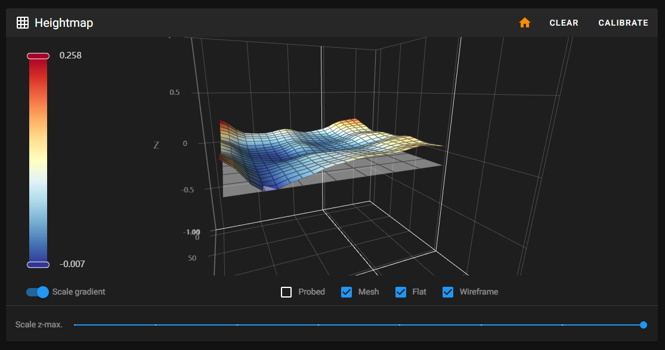

After: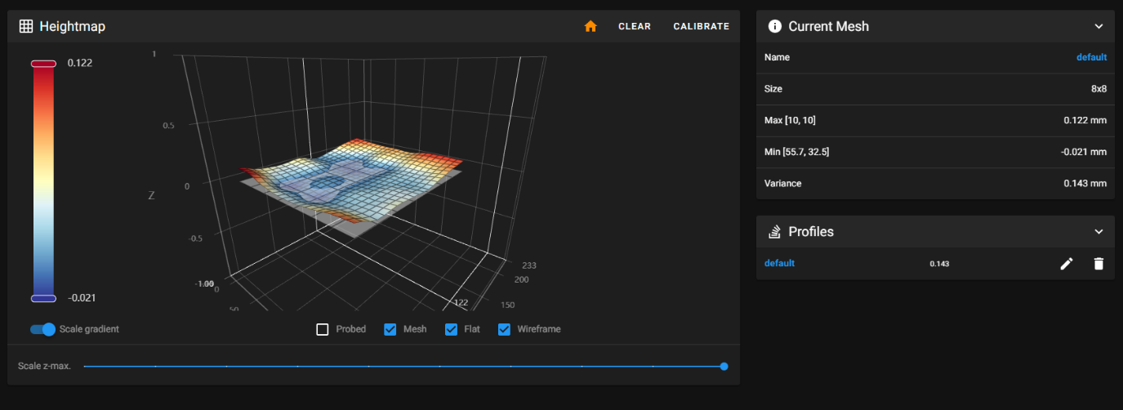

Not shown: the max variance in the original mesh was around 0.256.

First up, clear your current bed levelling mesh, and remove your Z-probe offset.

1. Loosen the Y belt tensioner on the front of the machine so that there is slack in the belt.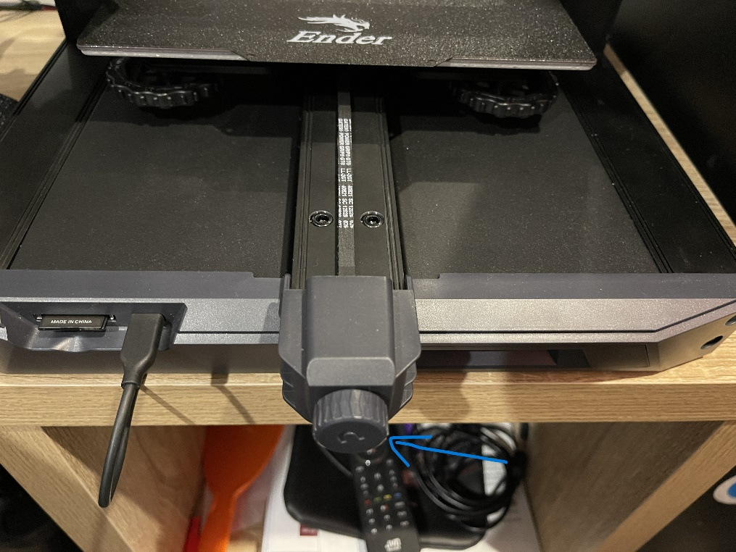
2. Undo the 4 bed levelling knobs on the bottom of the bed completely, and remove the bed from the bed carriage. Set it behind the printer, do not undo the heated bed cables.
3. Remove the bed carriage belts from the bed carriage by twisting them out of the slots they sit in in the front and back of the carriage.
4. At this point, your bed carriage should no longer be attached to the belts, and by extension no longer attached to the Y motor. You should be able to slide it around the Y axis with no friction. If you feel friction in some areas, but not in others – that means your Y axis is bolted too tightly to the frame, which is causing it to warp and bend, which also means it is going up and down along the Z axis at different areas along the length of the Y axis. This is what we are going to fix.
5. Pull the bed forward and undo the four long bolts attaching the Y axis aluminium extrusion to the central frame extrusion of the printer.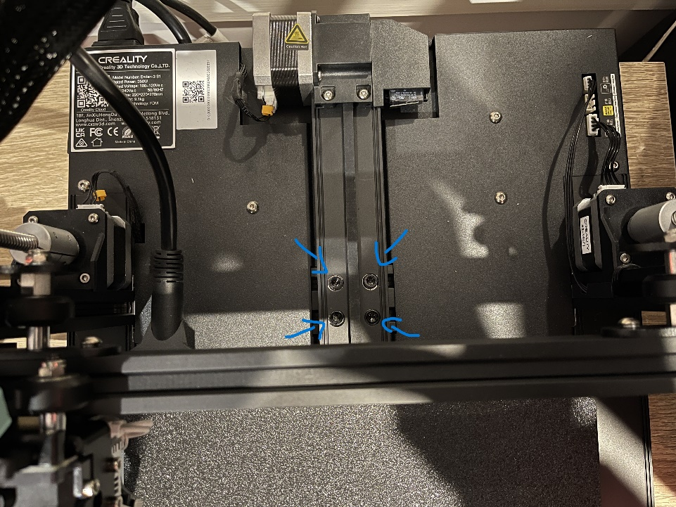
6. Push the bed backwards, and remove the 2 bolts at the front of the machine that hold the front of the Y axis to the main body of the printer.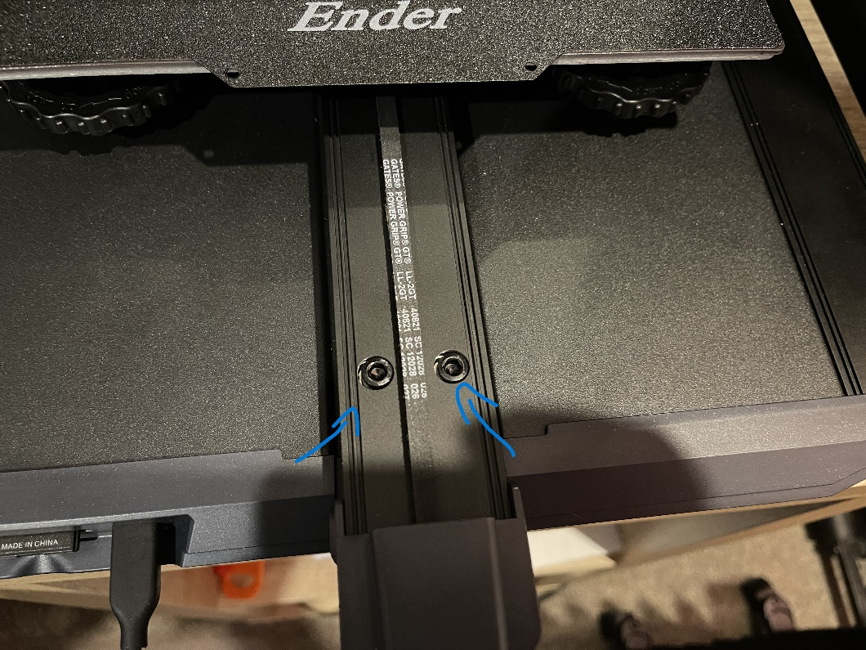
7. Remove the Y axis motor cable, and the Y end-stop cable.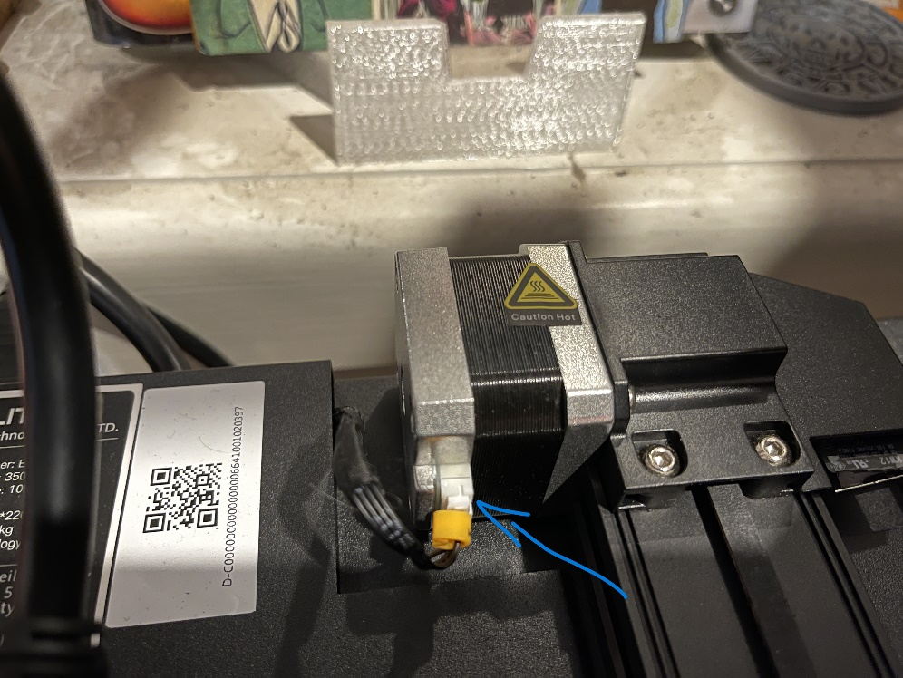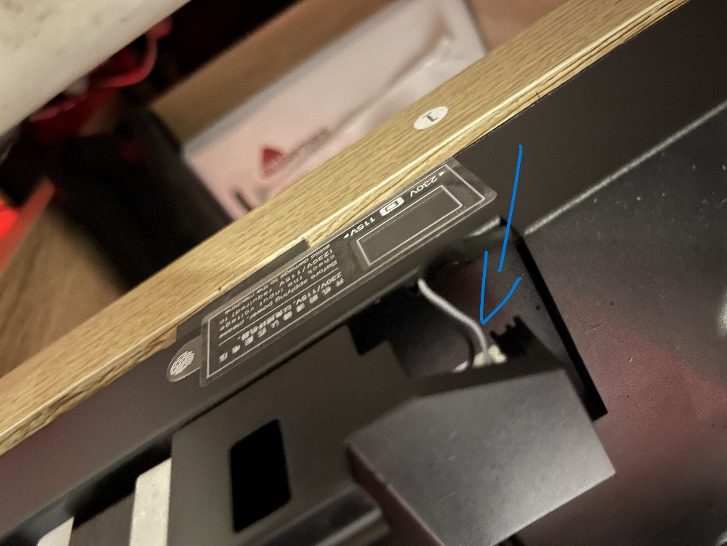
8. At this point, your entire Y axis should be able to be completely removed from the printer in one assembly, with the heated bed staying attached to the printer by its cables, being free of the bed carriage.
9. Observe with a straight edge if you have one (if not, a granite/stone kitchen bench can be used, or a desk, or anything else that you know to be relatively straight). If the aluminium extrusion appears straight – that’s good! That means that you can fix the issue by doing the following steps.
10. Place the Y axis back on to the printer, and tighten the bolts back down, BEING CAREFUL to not overtighten. They should get to the point where a reasonable amount of force is required, but you should not be cranking them down.
11. Once you have done this, try running the carriage along the Y axis again. You should not feel any tight spots, or any areas where it requires more force to move. If you can still feel friction in certain areas, try loosening the bolts at the front a bit more, or shimming with a piece of plastic, or wood, or metal, to get it to the point that the Y axis is smooth across the entire length of the extrusion.
12. Reattach the belt to the carriage by twisting it on to the loops at the front and back of the carriage.
13. Reattach the Y axis motor, and the Y axis endstop.
14. Reattach the bed to the carriage, using the bed levelling knobs.
15. Tighten your Y axis belt with the adjuster at the front of the printer. It should be tight enough to remove all slack, and still have some spring when you push down and release it.
16. Run through manual bed levelling to get all four corners relatively within spec.
17. Run through ABL using your preferred method. My testing has shown that it doesn’t matter if the extruder motor is engaged, or if the heating is on. It does not change the measurements.
18. Set z-probe offset using your favourite method.
19. Take a screenshot of your new bed mesh, and compare against the old one. Hopefully, you will notice it is much flatter, and much more true to life, with none of the strange artifacts that were known to plague this model of printer.